44.47: The available energy must be at least the sum of the final rest masses. So 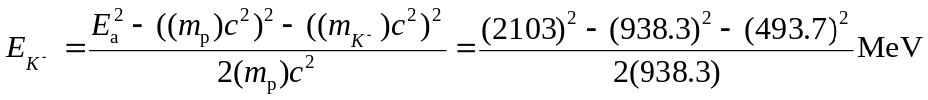
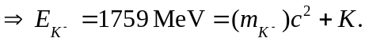
So the threshold energy K = 1759 MeV– 493.7 MeV=1265 MeV.

